Content Marketing Editorial Board System

Objective & Business Problem
Objective:
To build a multi-agent AI system that simulates a professional editorial board, ensuring marketing content is engaging, factually accurate, SEO-optimized, and aligned with brand voice.
Business Problem:
Modern businesses rely heavily on AI for content generation, but face persistent challenges:
- Content often sounds generic or robotic.
- Lack of brand voice consistency.
- Factual inaccuracies and outdated claims.
- Weak SEO optimization.
- Heavy manual editing required before publication.
This system addresses these pain points by automating editorial refinement through specialized agents.

Architecture
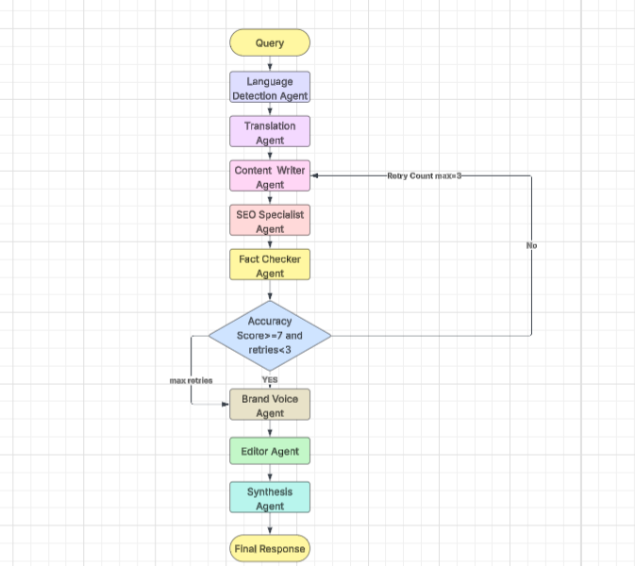
The system is designed as a multi-agent workflow, where each agent acts like a member of an editorial board:
- Language Detector Agent → Identifies input language.
- Translation Agent → Converts queries into English (and back to target language at the end).
- Content Writer Agent → Drafts the initial article.
- SEO Specialist Agent → Optimizes keywords, headings, readability, and adds metadata.
- Fact Checker Agent → Validates claims using search grounding and flags inaccuracies.
- Brand Voice Agent → Ensures tone, style, and vocabulary match brand guidelines.
- Editor Agent → Performs final grammar, flow, and quality review.
- Synthesis Agent → Produces the final polished output with metadata.
The agents are orchestrated via a LangGraph pipeline with conditional routing:
- If fact-checking accuracy < 7/10 and retries < 3, the draft loops back to the Content Writer for revision.
- Otherwise, the pipeline proceeds to Brand Voice → Editor → Synthesis.

Approach / Pipeline
- Input Query → User provides a topic.
- Language Detection & Translation → Ensures English baseline.
- Draft Generation → Content Writer produces a structured article.
- SEO Optimization → Keywords, headings, meta description, FAQ.
- Fact Checking → Validates statistics, dates, claims.
- Accuracy Evaluation → Retry loop if needed.
- Brand Voice Alignment → Tone/style consistency.
- Editorial Review → Grammar, flow, readability.
- Synthesis → Final content + metadata report.

Features & Limitations

Features:
- Multi-stage refinement for high-quality output.
- Role-based specialization (writer, SEO, fact checker, editor).
- Iterative feedback loops for accuracy.
- JSON-structured outputs for reproducibility.
- Brand voice enforcement for consistency.

Limitations:
- Dependent on API reliability (errors can halt pipeline).
- Fact-checking limited by available search grounding.
- Retry loop capped at 3 passes (may still leave minor inaccuracies).
- Requires clear brand guidelines for optimal alignment.

Results
- Improved Content Quality: Articles are more engaging, structured, and polished.
- Consistency: Brand voice maintained across all outputs.
- Accuracy: Fact-checking loop reduces misinformation.
- Efficiency: Cuts down manual editing time by >50%.
- SEO Performance: Optimized headings, keywords, and meta descriptions improve organic reach.

Conclusion
The Editorial Board System demonstrates how a multi-agent AI pipeline can replicate the collaborative process of a professional editorial team. By combining writing, SEO, fact-checking, brand alignment, and editorial review, the system produces content that is accurate, consistent, and impactful.

Impact
- Business Impact: Faster content production, reduced manual effort, improved brand trust.
- Marketing Impact: Higher SEO rankings, better audience engagement, stronger brand identity.
- Operational Impact: Scalable editorial workflows, reproducible quality, and measurable performance metrics.

